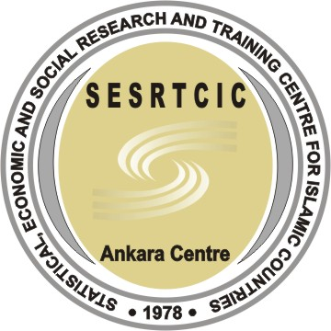
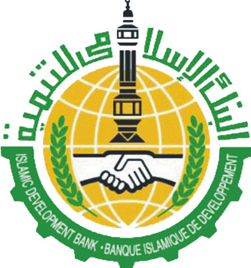
Workshop Agenda

"Micro–Credit Financing and Poverty Alleviation in OIC Member States"

Day 1, 9 July 2007
08:00 | Registration
09:30 | Opening Remarks | – OIC General Secreteriat, Albaraa Tarabzouni  – ADFIMI, Mr. Nuri Birtek  – COMCEC, Ferruh Tığlı  – Bahrain Development Bank, Mr. Nedal Al–Aujan  – SESRTCIC, Dr. Savaş Alpay
10:30 | Coffee Break
11 :00 | SESSION 1  Challenges Facing the Microfinance Sector in Developing Countries | – Islamic Development Bank (S.Arabia) – Mr.Abdulaziz Sloaui  – UNCDF, (South Africa) – Mr. Abdoul Anziz Said Attoumane  – Asian Development Bank (Philippines) – Mr. Nimal A. Fernando  – Saudi Credit and Savings Bank, (S. Arabia) –Abdulrahman Sehebani
12:30 | Lunch & Prayer Break
14 :00 | SESSION 2  Meso Issues in Micro Finance (Networking, Training & Technical Cooperation) | – Islamic Development Bank (S.Arabia) – Mr. Raja Mohammad Anayat  – FINCA International (Afganistan) – Mr. Mostaq Ahmmed  – UNCDF (South Africa) – Mr. Abdoul Anziz Said Attoumane  – Sanabel (Egypt) – Dr. Youssef Mohammad Fawaz  – PlaNet Finance (Benin)
16 :00 | Coffee Break
16:30 | SESSION 3  General Discussion on Project Ideas | Parallel Sessions
17 :30 | End of First Day
19 :30 | Welcome Reception and Dinner

Day 2, 10 July 2007
9 :00 | SESSION 4  Microcredit in Financing SMEs | – KOSGEB (Turkey) – Ms. Nedret Uğur Yavuz  – ICCI – (Pakistan) – Ms. Attiya Nawazish Ali  – ICDT (Morocco) – Sall Amadou Cire
10 :30 | Coffee Break
11 :00 | SESSION 5  Success Stories | – BRAC (Bangladesh) – Mr .Husain I. Adib  – BRI (Indonesia) – Mr. Ismanto  – Grameen Trust (Bangladesh) – Prof. H. I. Latifee
12 :30 | Lunch & Prayer Break
14 :00 | SESSION 6  Innovative Practices | – Qardul Hasan Funds (Iran) – Mr. Abbas Arabmazar  – Zakoura Foundation (Morocco) – Mrs. Aicha El Hammoumi  – MAYA Foundation, (Turkey) – Ms .Belgin Güzaltan  – Sanduq System, RCDP (UNDP, Syria) – Mr. Mahmoud Assad  – KIVA (USA) – Mr. Shelby Clark
16 :30 | Coffee Break
17 :00 | SESSION 7  General Discussion on Project Ideas | Parallel Sessions
18 :00 | End of the Workshop
Day 3, 11 July
09 :00–12 :00 | Visiting Topkapi Palace Museum

