
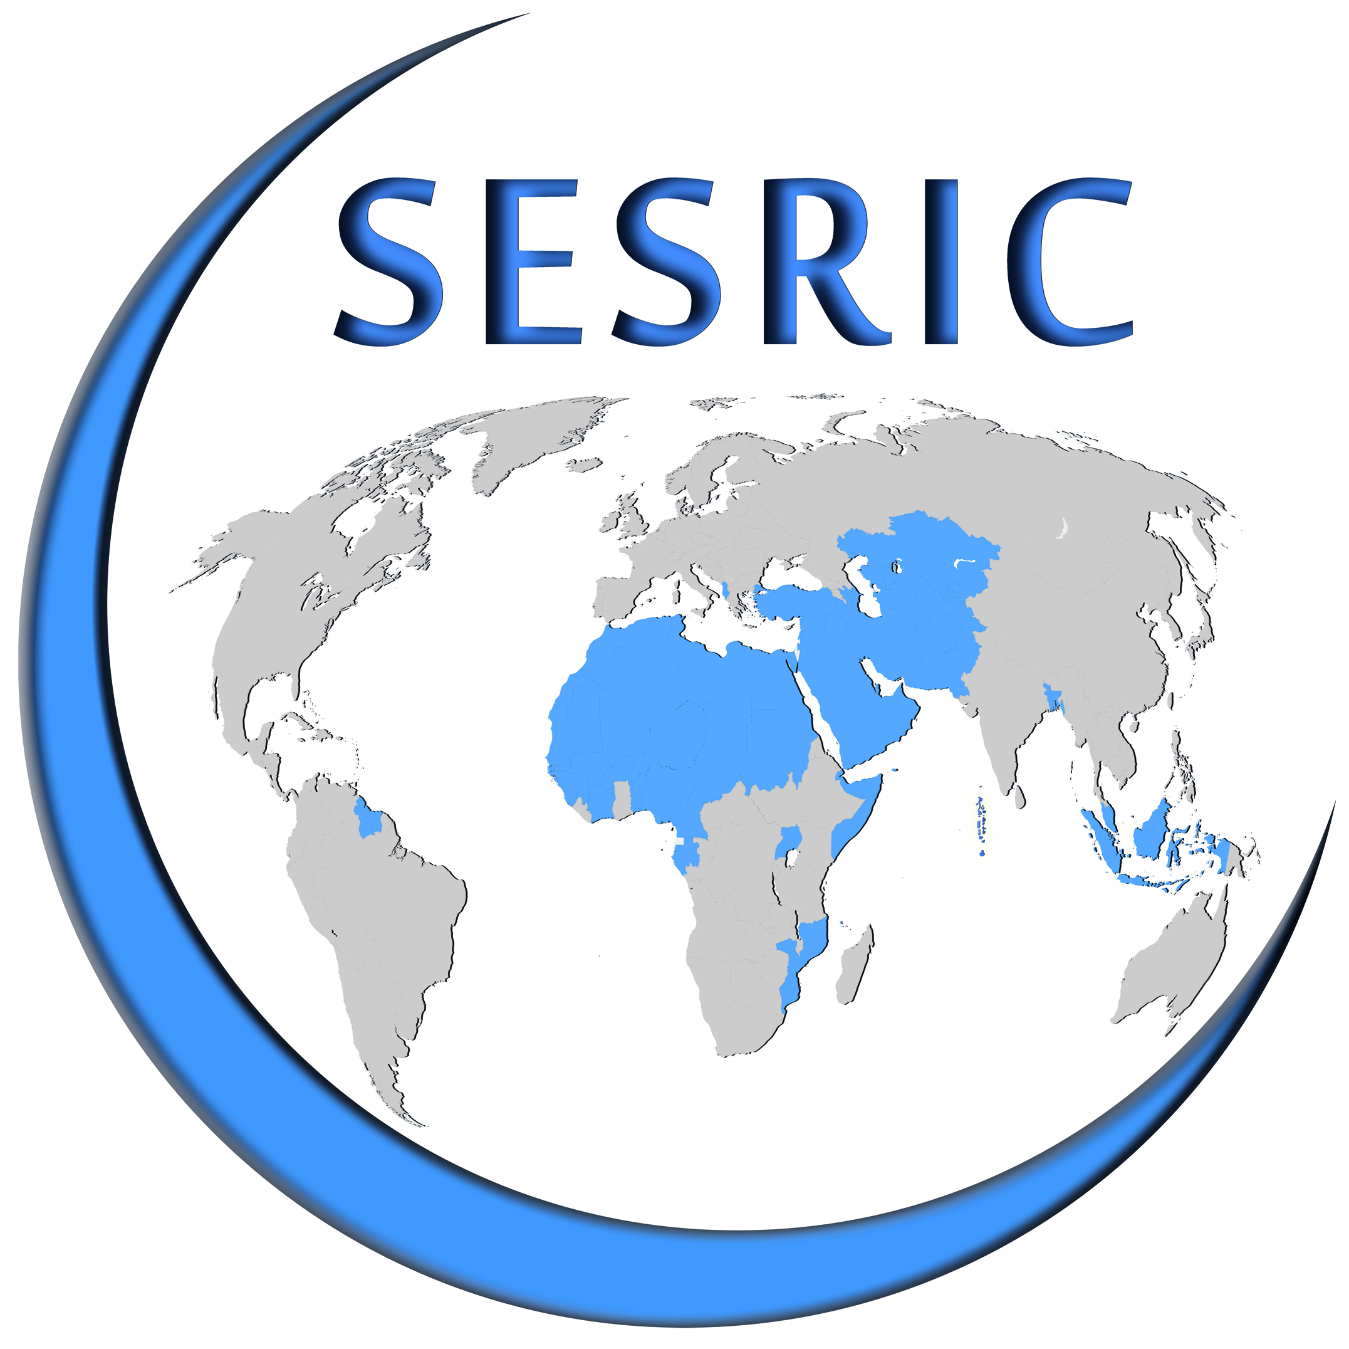
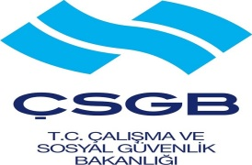


Workshop on
“Occupational Safety and Health Regulations and Standards”
4 May 2014
Haliç Congress Centre, İstanbul, Turkey
REGISTRATION FORM
Please fill in this form in capital letters and return one copy to:
training@sesric.org
latest by 15 April 2014

Country:
Institution:
Family Name:
First Name:
Position:
Phone:
GSM:
E-mail:
Fax:

Date: (Please check the box if you would like to attend the social programme)

