Central Bank Governors and Monetary Authorities of
the Member Countries of the Organization
of Islamic Cooperation (OIC)
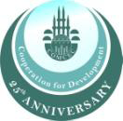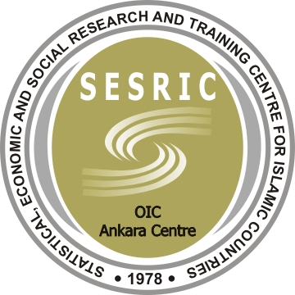

Experts Workshop on
“Promoting Strong and Stable Capital Flows among OIC Countries: Roles of the Financial Sector and Central Banks”

Swissotel The Bosphorus / Geneve Room

İstanbul

Registration Form
Please complete and send this form to;
Fax: +90 312 507 56 61
E-mail: protocol@tcmb.gov.tr
by April 30, 2012

Title and Full Name:

Organization and Position:

E-Mail:

Phone:

Mobile Phone:

I will be accompanied by: (Ms./Mr.)

Arrival Flight to Istanbul | Departure Flight from Istanbul
Arrival Airport: IST SAW | Departure Airport: IST SAW
Arrival Date: | Departure Date:
Arrival Time: | Departure Time:
Flight number : | Flight number :

Accommodation: We kindly ask you to arrange your hotel reservations by directly getting in contact with the hotels listed. It is highly recommended that you make your hotel reservations as soon as possible due to limited seasonal availability in May. For organizational reasons, we need to know which hotel you are staying at, so please write down the hotel of your choice below.

Participation to Other Meetings on May 15-17, 2012
Organization Name | Date | Time | Yes | No
IILM Meeting -Swissotel The Bosphorus/Luzern Room | May 15, 2012 | 14.30-17.30
IFSB Opening Reception-Swissotel The Bosphorus/Geneve Room | May 15, 2012 | 19.30
IFSB Meeting-Swissotel The Bosphorus/Asuka Room | May 16, 2012 | 08.30-17.00
IFSB Gala Dinner | May 16, 2012 | 19.00
IFSB Meeting-Swissotel The Bosphorus/Asuka Room | May 17, 2012 | 09.00-13.00

