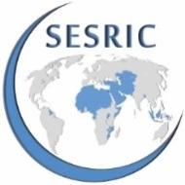 |   Study Visit on “Development of Sustainable Aquaculture for OIC Countries”  in Muğla and Izmir, Turkey 30 May – 03 June 2016 | 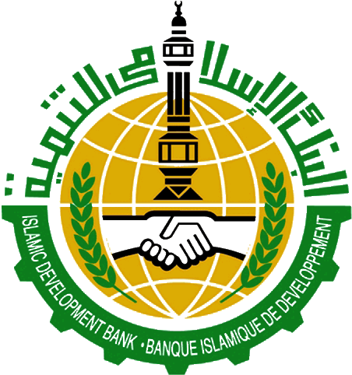

Participants Registration Form
Please fill in this form in capital letters and return to: aquaculture@sesric.org
Contact Details
Country
Institution
First Name
Family Name
Position/Designation
E-mail
Mobile Phone | Country Code |  | Area Code |  | Number
Landline Phone | Country Code |  | Area Code |  | Number
Fax | Country Code |  | Area Code |  | Number
Visa Need
What type of passport do you hold? (Service/Diplomatic/Ordinary)
Do you need a visa to enter the host country? (Yes/No)
Do you need an acceptance letter from the host institution for the facilitation of visa issuance? (Yes/No)

Please do not forget to attach your CV and Passport Copy

