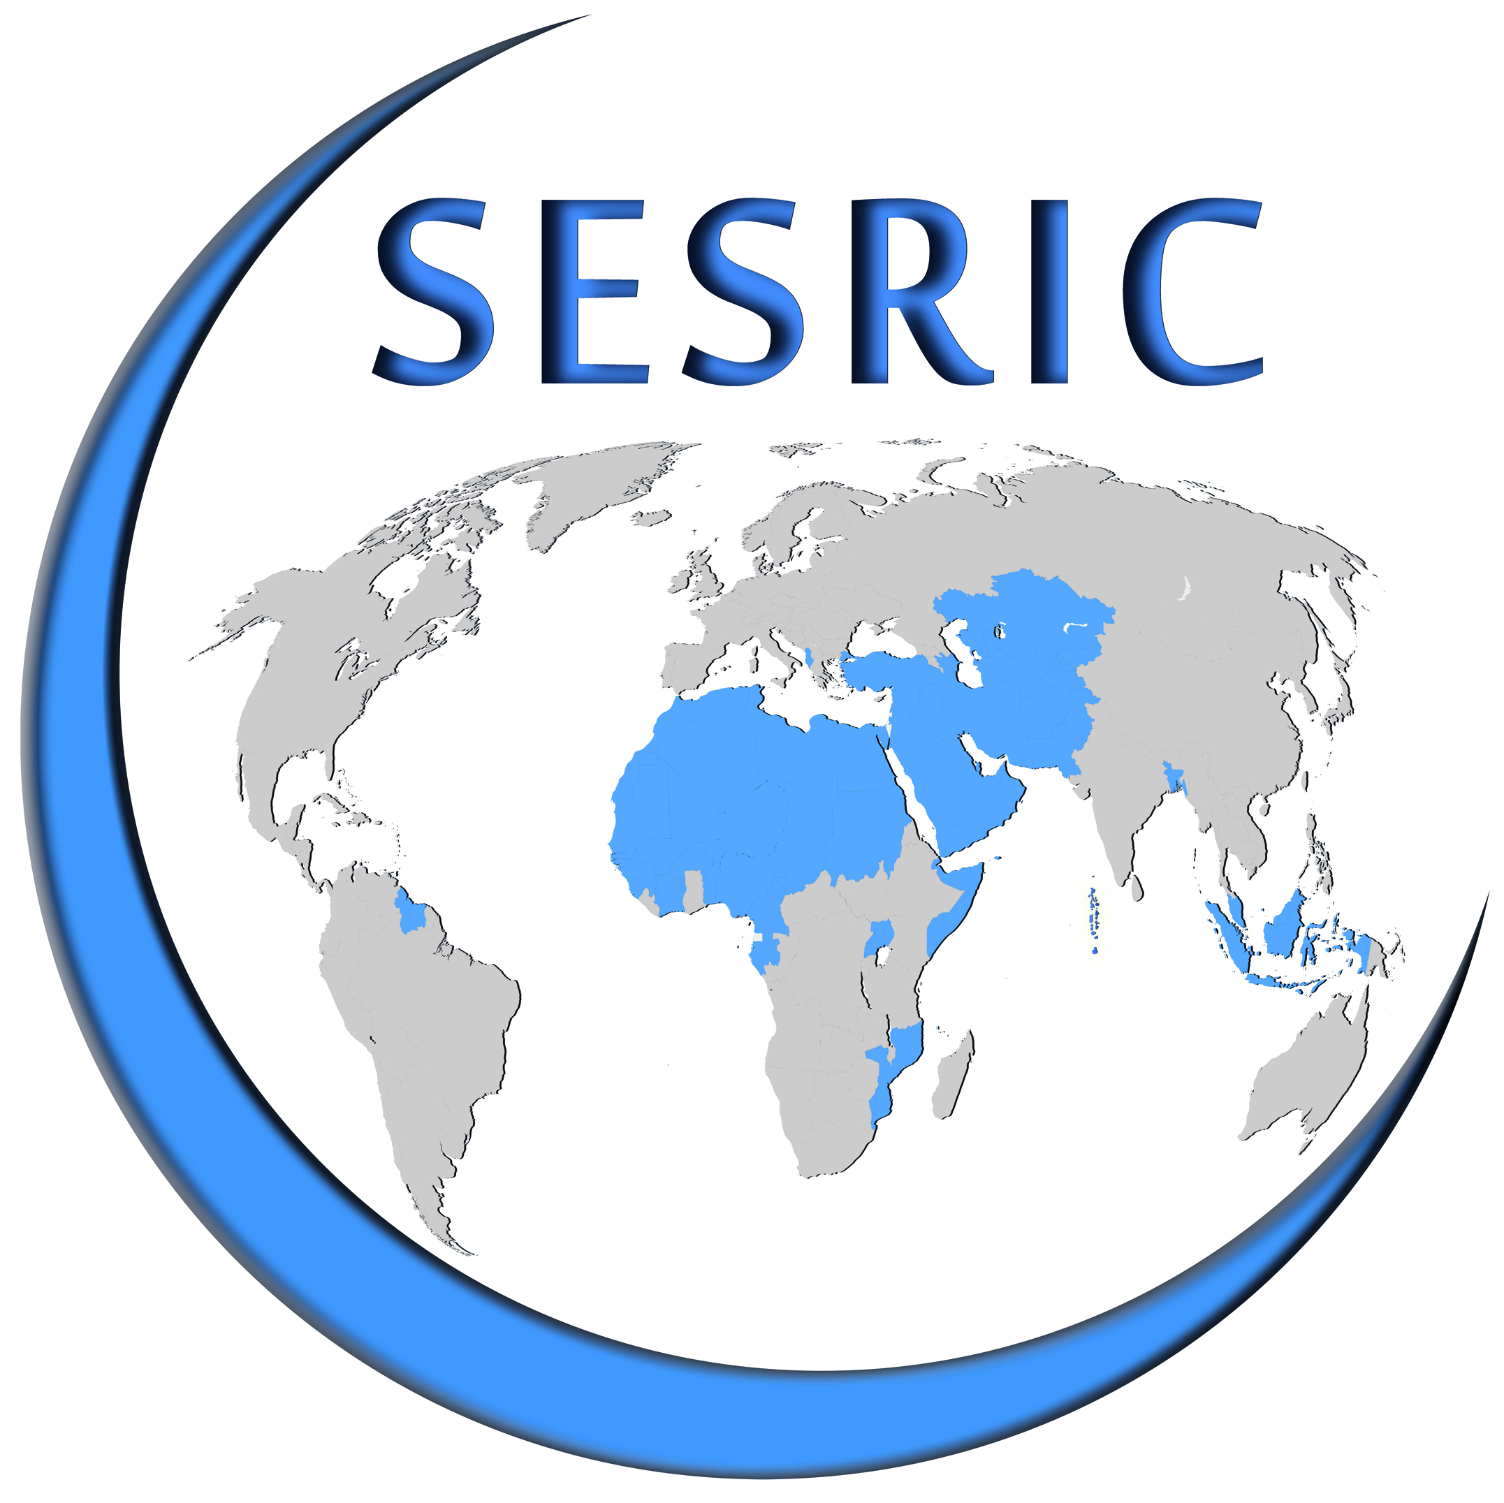
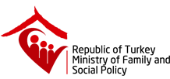

CONFERENCE ON EMPLOYMENT OF PERSONS WITH DISABILITIES IN OIC MEMBER COUNTRIES
26 - 28 October 2016
Radisson Blu Conference & Airport Hotel, Istanbul, Turkey
REGISTRATION FORM
Please fill in this form in capital letters and return one copy to:
disability@sesric.org
latest by 16 September 2016

Country:
Institution:
Family Name:
First Name:
Position:
Phone:
GSM:
E-mail:
Fax:

