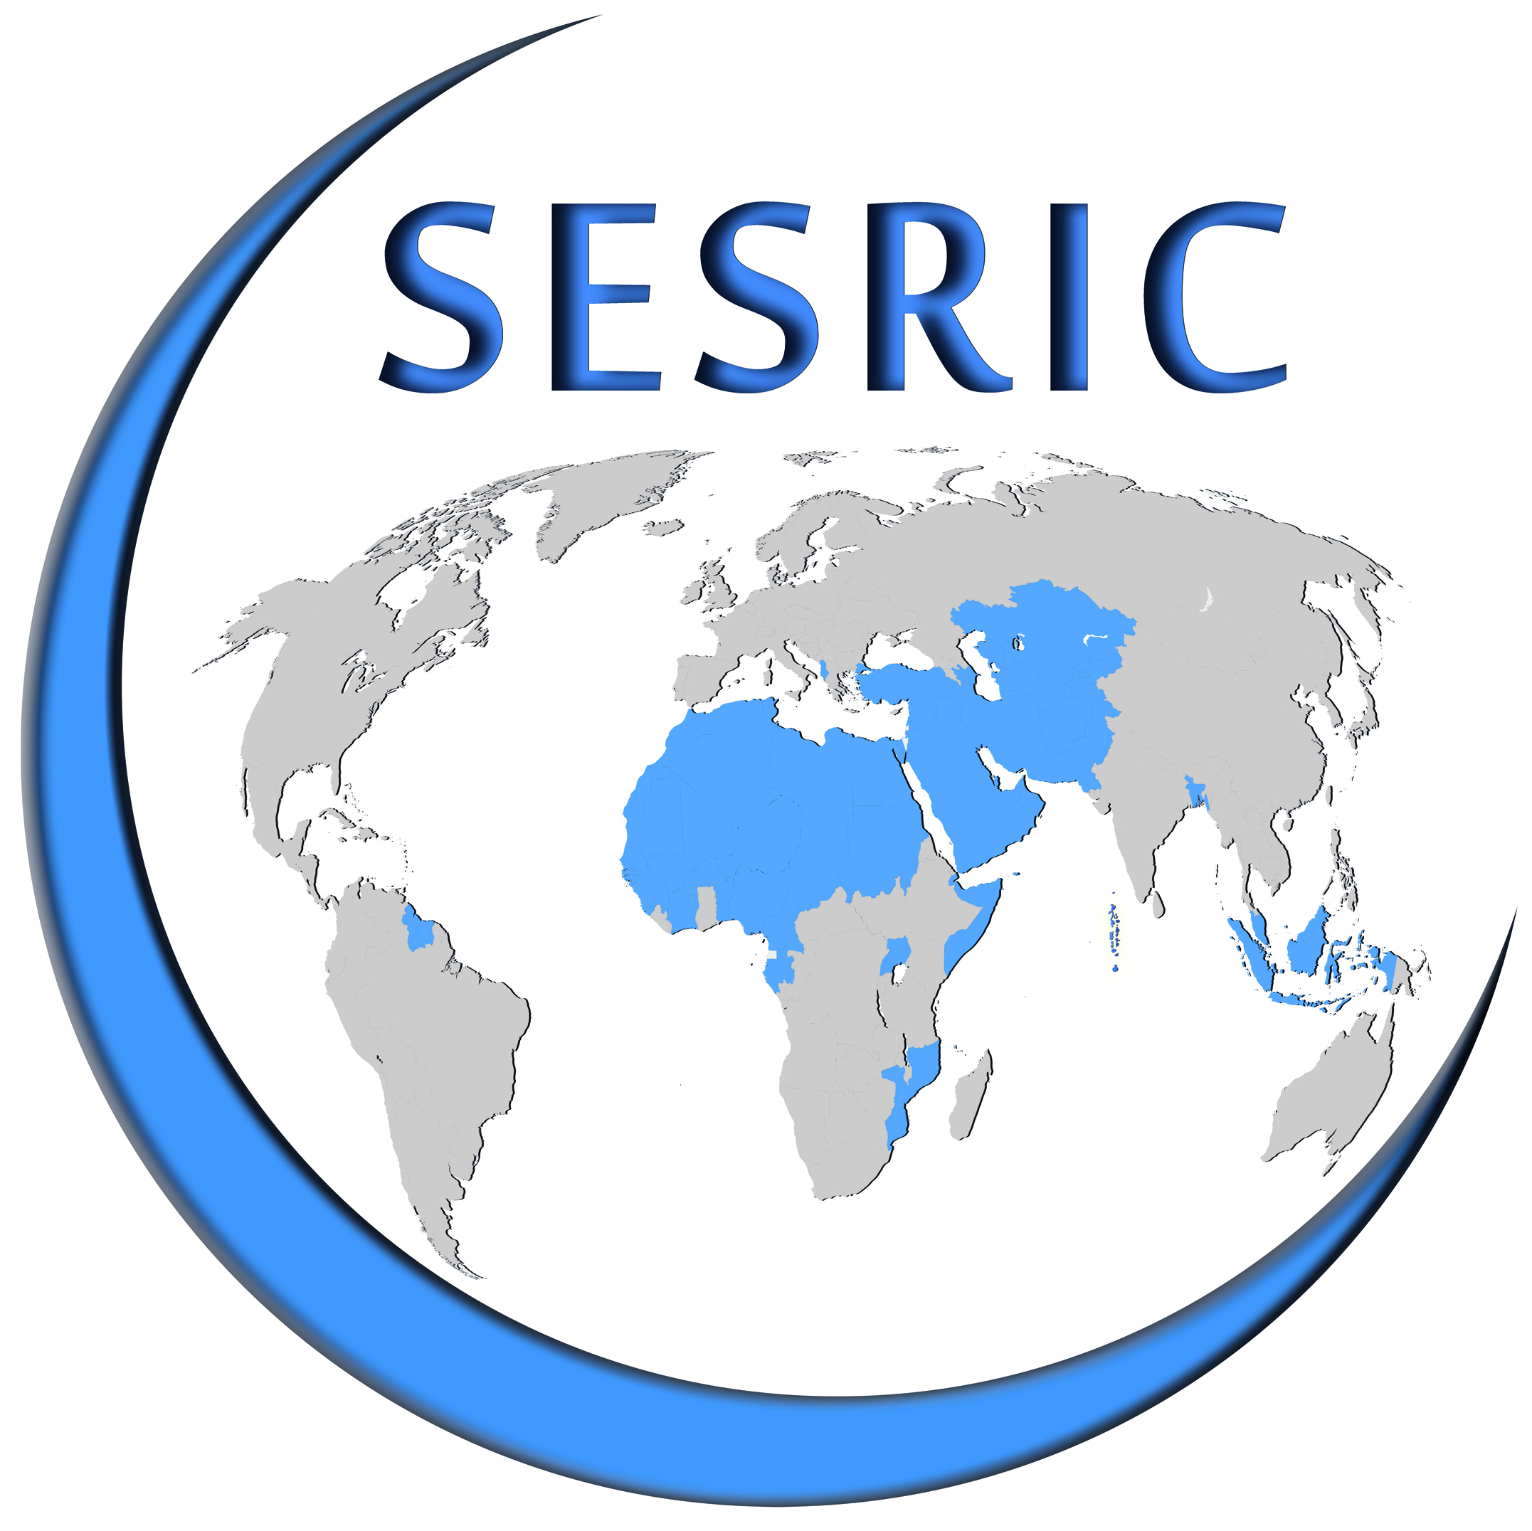
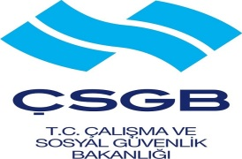


Third Meeting of OIC Occupational Safety and Health Network (OIC-OSHNET)

8 May 2016
Haliç Congress Centre, İstanbul, Turkey
REGISTRATION FORM
Please fill in this form in capital letters and return one copy to:
training@sesric.org
latest by 10 April 2016

Country:
Institution:
Family Name:
First Name:
Position:
Phone:
GSM:
E-mail:
Fax:

